Week- 5

Skill name : Microservices with Spring Boot 3 and Spring Cloud

Handson-1 : Creating Microservices for account and loan

**Step 1:**

Create folder with employee id in D: drive • Create folder named 'microservices' in the new folder created in previous step. This folder will contain all the sample projects that we will create for learning microservices.

Step 2:

Open https://start.spring.io/ in browser

• Enter form field values as specified below:

Group: com.cognizant o Artifact: account

• Select the following modules o Developer Tools > Spring Boot DevTools o Web > Spring Web

• Click generate and download the zip file

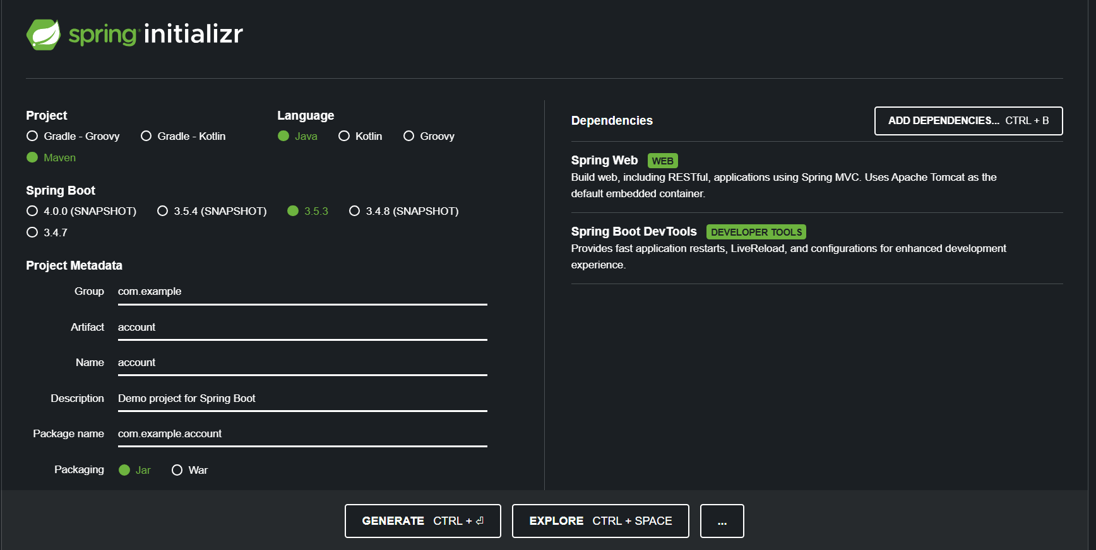

Step 3 :

mvn clean package

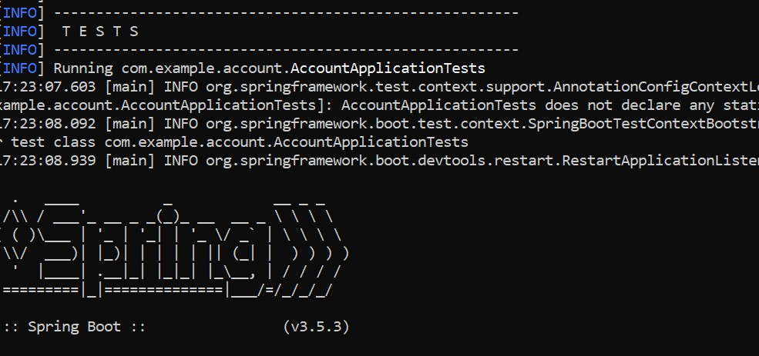

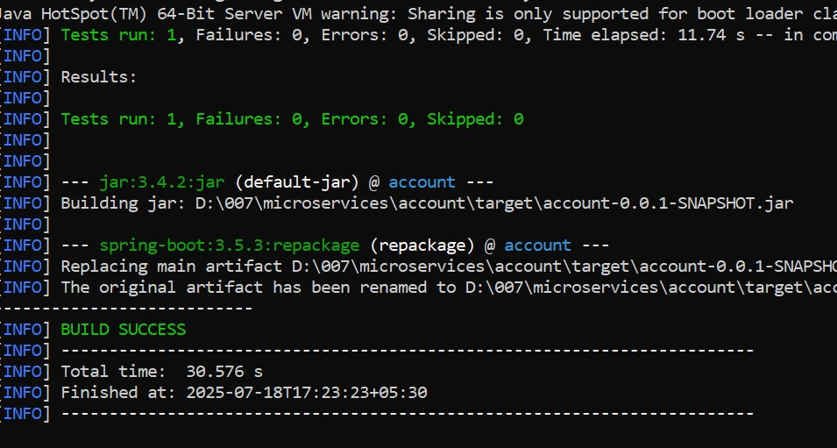

Step 4:

//LoanController.java

package com.cognizant.loan.controller;

import org.springframework.web.bind.annotation.*;

@RestController

@RequestMapping("/loans")

public class LoanController {

@GetMapping("/{number}")

public Loan getLoan(@PathVariable String number) {

return new Loan(number, "car", 400000, 3258, 18);

}

static class Loan {

private String number;

private String type;

private double loan;

private double emi;

private int tenure;

public Loan(String number, String type, double loan, double emi, int tenure) {

this.number = number;

this.type = type;

this.loan = loan;

this.emi = emi;

this.tenure = tenure;

}

public String getNumber() { return number; }

public String getType() { return type; }

public double getLoan() { return loan; }

public double getEmi() { return emi; }

public int getTenure() { return tenure; }

}

}

